SOL 1:

//Program to take your roll number as input and calculate the sum of first and third digits

#include<stdio.h>

/\* Function to get sum of first and third digit \*/

int getSum(int n)

{

int first = 0,third=0;

first= n % 10;

n = n / 100;

third=n%10;

return first+third;

}

// Driver code

int main()

{

int r=0;

printf("Please enter your roll no:");

scanf("%d",&r);

printf("%d", getSum(r));

return 0;

}

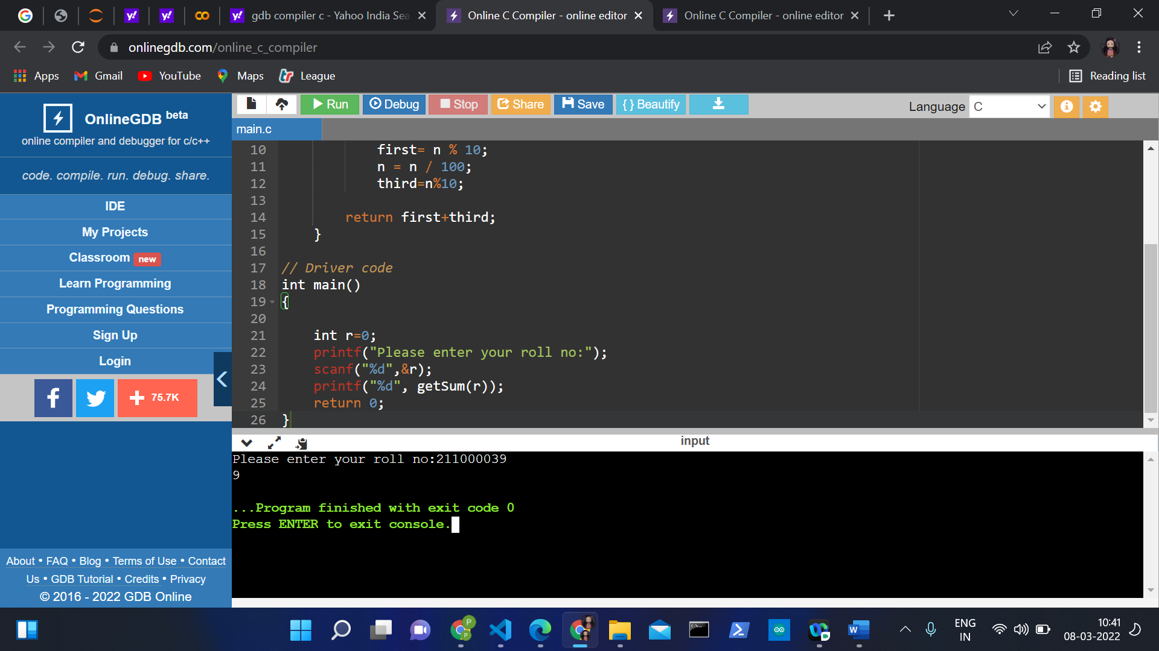

SOL 2:

#include <stdio.h>

int fact(int n);

int main()

{

int a,b,n,res;

printf("Enter roll number:");

scanf("%d",&a);

printf("Enter age:");

scanf("%d",&b);

n= a%b;

res=fact(n);

printf("n!=%d\n",res);

return 0;

}

int fact(int n)

{

int res;

if (n==0)

{

return 1;

}

else

{

return n\*fact(n-1);

}

}

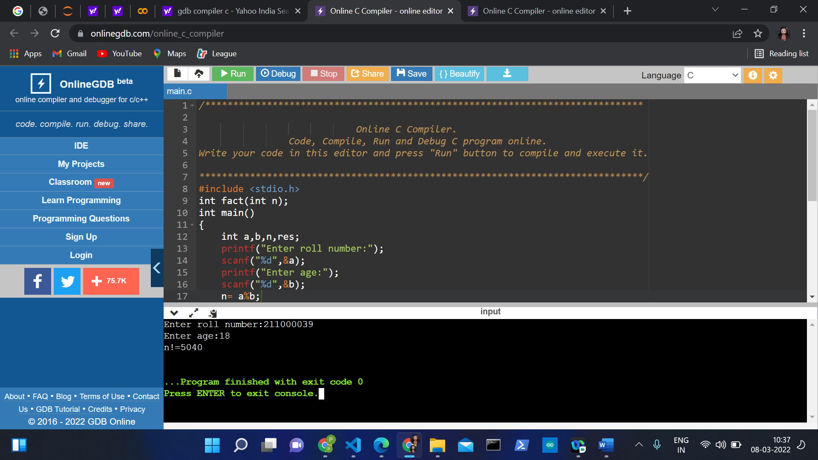

SOL 3:

#include <stdio.h>

int main()

{

char str[100];

char \*p;

int vCount=0,cCount=0;

printf("Enter your name: ");

fgets(str, 100, stdin);

p=str;

while(\*p!='\0')

{

if(\*p=='A' ||\*p=='E' ||\*p=='I' ||\*p=='O' ||\*p=='U'

||\*p=='a' ||\*p=='e' ||\*p=='i' ||\*p=='o' ||\*p=='u')

vCount++;

else

cCount++;

p++;

}

printf("Number of Vowels in String: %d\n",vCount);

printf("Number of Consonants in String: %d \n",cCount);

printf("Total characters: ");

printf("%d",vCount+cCount-1);

return 0;

}

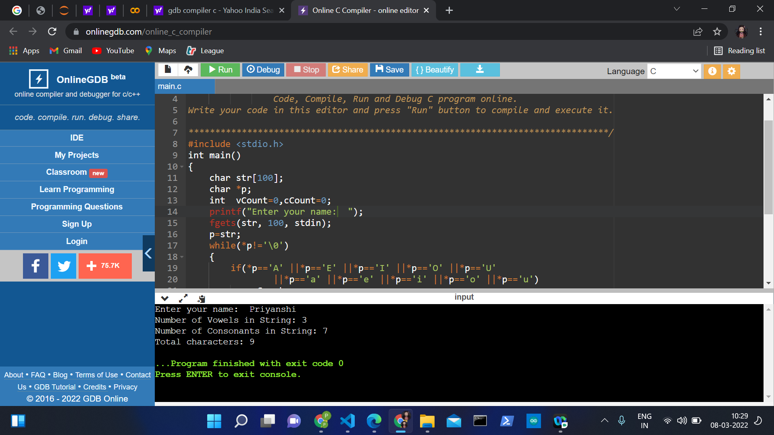

SOL 4:

#include<stdio.h>

void main()

{

int output1,output2;

printf("Enter Two Number : ");

scanf("%d%d",&output1,&output2);

calc(output1,output2);

}

calc(int x,int y)

{

int z;

z=x\*y;

printf("Multiplication of Two Number is : %d",z);

return 0;

}

